ELEN90051 ADVANCED COMMUNICATION SYSTEMS

Digital Communication Systems in GNU Radio

Workshop week 5: QPSK Modulation

Junbin Zhong 819870

**Introduction**

In analog communication systems, the information from the transducer has continuous values. It can be directly modulated by carriers in the modulator in the transmitter. In the receiver, the information can be restored after demodulator. In digital communication systems, information from the transducers will go through a source encoder and a channel encoder, where the efficiency and the robustness of the information are improved. It also requires a digital modulator to up-shift the bit sequence onto the band-pass region. In the receiver, the output of the channel goes through the digital demodulator, channel decoder and source decoder before the information is restored.

There are many reasons of using digital communications. The digital system can tolerate more noise and distortion, achieve data compression and remove information redundancy with source coding, introduce new redundancy to tackle channel noise with channel coding, have flexible bandwidth and power trade-off, and incorporate cryptographic techniques. All those features lead to the low-cost, long-range, and high-speed systems.

There are mainly three types of digital modulation, including amplitude shift keying (ASK), frequency shift keying (FSK) and Phase shift keying (PSK).

**Background**

Complex numbers contain a real part and an imaginary part, which can be represented in a two-dimensional coordinate. Signal space is a vector space consisting of functions, where each function can be represented by a set of orthogonal and normal bases. Gray coding suggest that adjacent phases differ by only one bit, which results in a better average bit error rate.

The connection between digital signals and analog waveforms is that, in the interval 0 to T, the signal form is the product of the digital value and the analog waveform, which means Sm(t) equals Am by p(t).

The advantage of using high-order modulation schemes is the higher rate of transmission, because with more bits in a symbol, the signal in the fixed interval 0 to T contains more information. The disadvantage is the higher sensitivity to noise, because a smaller shift in the phase, amplitude, or frequency will incur symbol errors.

**Implementation**

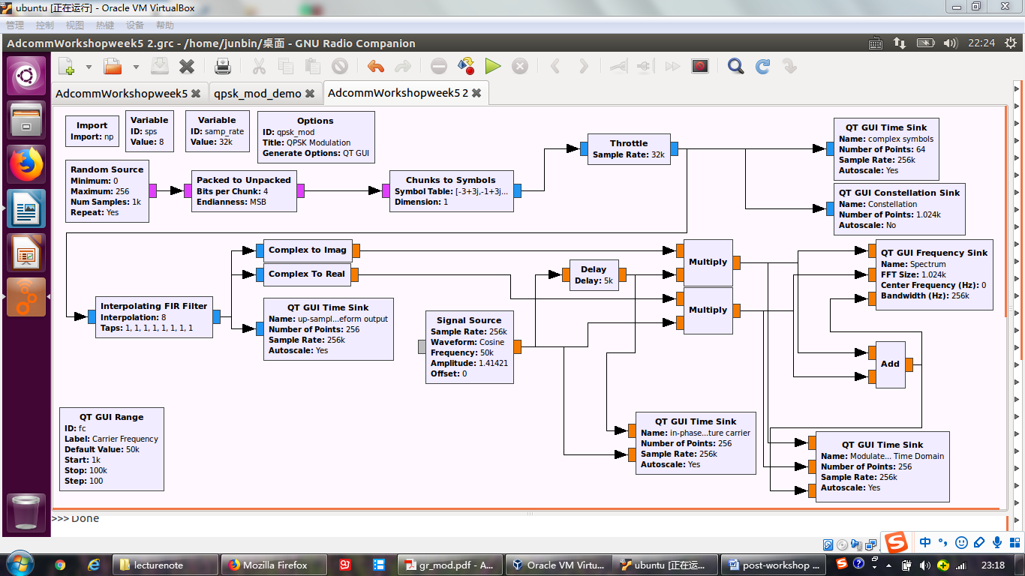

The random source block

The random source block generates a random bit sequence, which is used as the transmitted information. In reality, this can be the output of the channel encoder with different types of information source, such as images, audio, video etc.

The packed to unpacked block

The packed to unpacked block works as a serial to parallel converter. To meet the requirement of our 16-QAM modulation scheme, bit sequence needs to be parsed into 4-bit chunks, because 2 to the power of 4 is 16.

The chunks to symbols block

The chunks to symbols block maps the 4-bit chunks onto a point of the signal constellation. Since one chunk has 4 bits, there are 16 different points in the signal constellation.

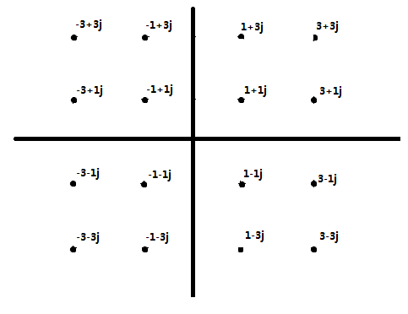

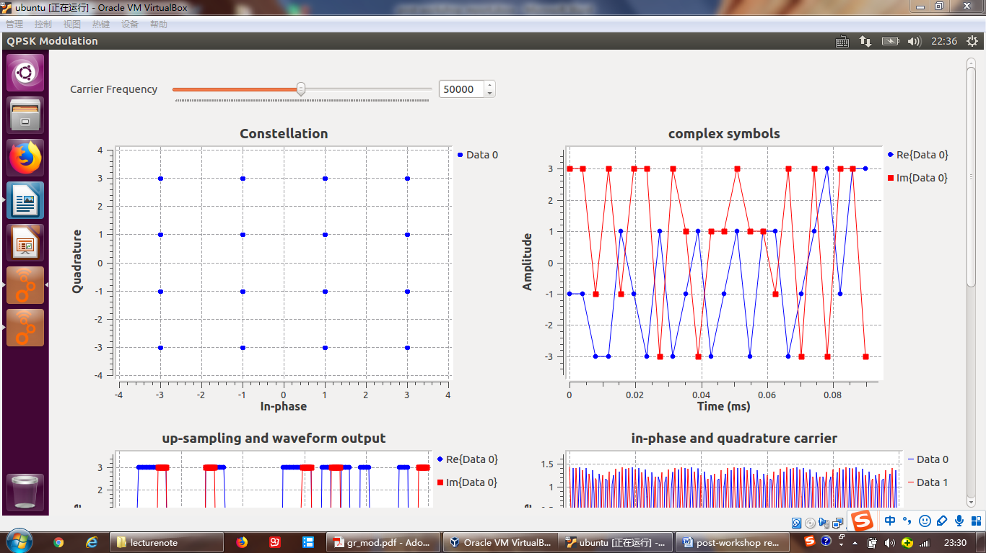

The generated constellation diagram is identical to my design, and the complex symbol diagram is composed of two curves, one for the real part, the other for the imaginary part, both of which take values of -3, -1, 1, 3.

The throttle block

The throttle block limits the computation speed to avoid the overloading of CPU.

The interpolating FIR filter

The interpolating FIR filter has two functions. One is to up-sample both the in-phase and quadrature parts of the sequence. The other is pulse shaping. As the taps are 1,1,1,1,1,1,1,1, each of the input values is expanded to a discrete rectangular pulse with the length of 8 bits. Hence, the sample rate from now on is eight times the previous sample rate due to the up-sampling.

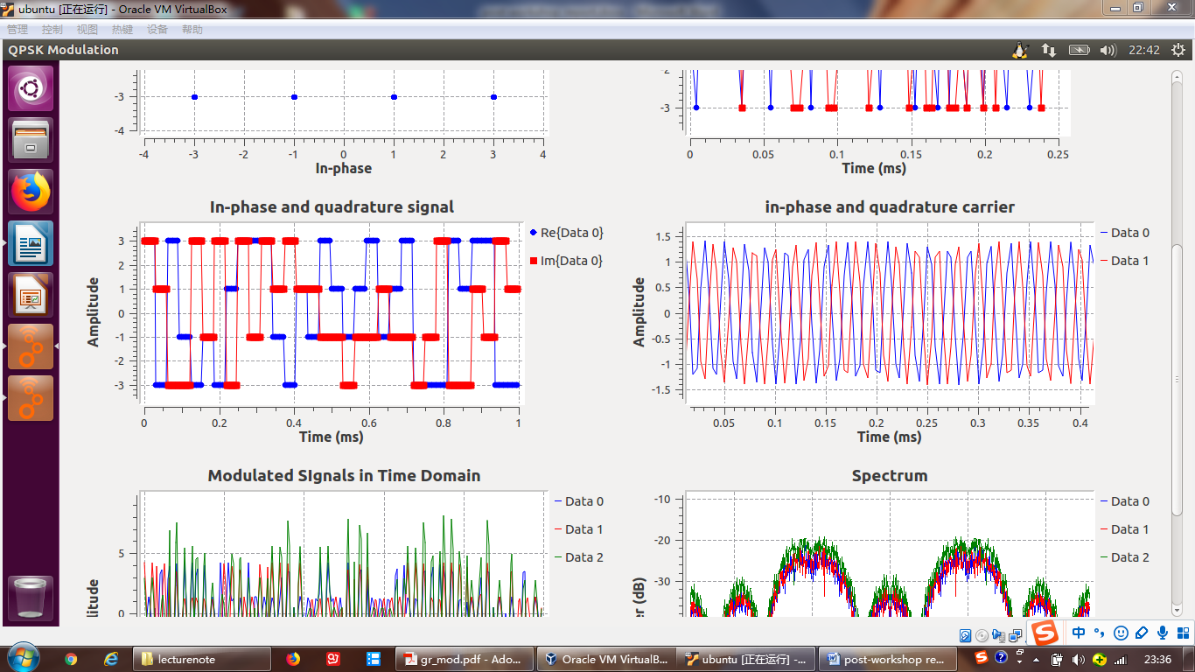

The generated in-phase and quadrature signals are the expanded sequence of the original input sequence.

The complex to real/imag block

The complex to real block extracts the real part of the filter output as the in-phase component, and the complex to imag block extracts the imaginary part as the quadrature component.

The signal source generates the sinusoidal carrier with the frequency fc=50k Hz.

The delay block creates the 90 degree phase shift. Since the frequency fc=50k Hz, the correct delay is tau=(10^9)/(4*fc) nanoseconds.

As observed from the carrier diagram, two carriers are out of phase by 90 degrees.

The multiply block

The multiply block achieves the multiplication between in-phase component and in-phase carrier, the other multiply block achieve the multiplication between quadrature component and quadrature carrier.

The add block

The add block adds two components together and generates the signal that is ready to transmit into the channel.

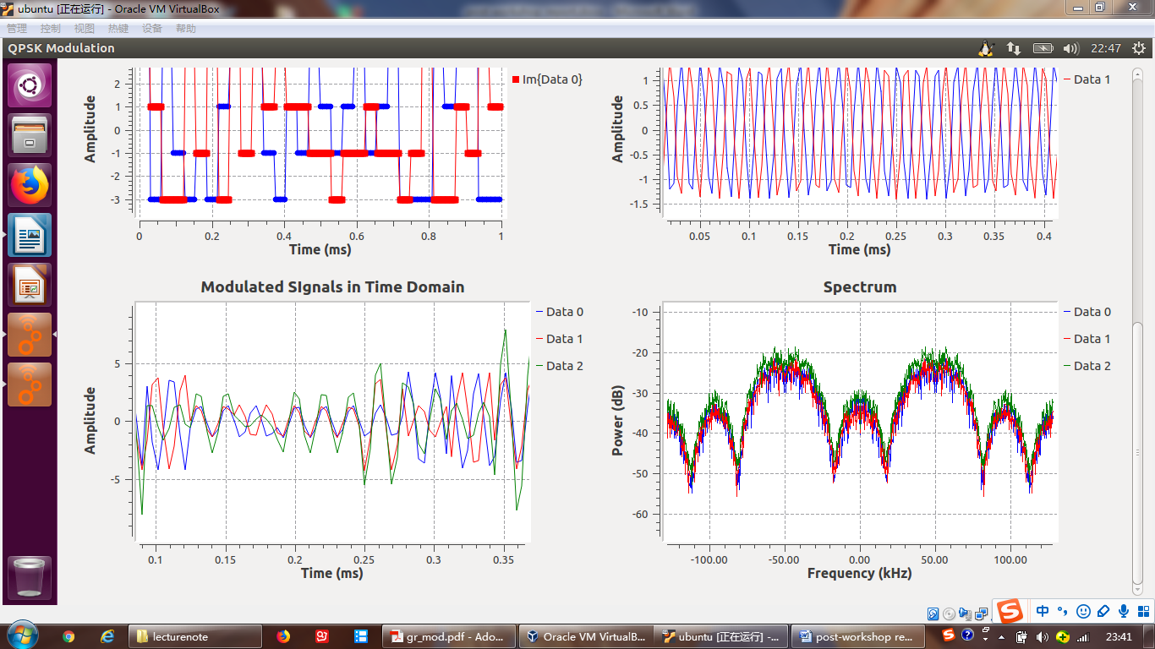

The combined signal, which is indicated by the green color, is the sum of the in-phase and quadrature components, and the spectra of the in-phase, quadrature and combined signals are similar, with peak frequencies at 50k Hz. Since the base band pulse shape is the rectangular pulse, the pass band spectrum is the up-shifted SINC function, which is also observed from the diagram.

**Conclusion**

By parsing the bit sequence into chunks of 4 bits, we managed to map symbols onto points in signal constellation and achieved 16-QAM. The complex signal is represented by in-phase and quadrature components, and the original information is now embedded in the amplitude and phase of the output signal.

In the workshop experiments, we implemented two schemes, including QPSK and 16-QAM. The advantage of QPSK is the immunity to the amplitude distortion, because information is embedded in the phase, but the drawback is the slow rate, because only two bits are transmitted in one time interval T, which also means one symbol contains only 2 bits. On the other hand, the 16-QAM is sensitive to the amplitude distortion, while it transmits bits in a faster speed.

One possible issue of receiver is the noise in the received signal added by the channels. Another is the difficulty in carrier synchronization.

The receiver can decide the transmitted symbol by comparing the error probabilities. The one with the smallest error probability is the retrieved symbol.